**Github link https://github.com/VamshidharReddyTurpu/datapart3**

**ERD Model PART 3**

Illustrate that you understand normalization and how to use it to reduce uncontrolled redundancy in your database design by creating two ERD diagrams:

**Answer:**  In this reformation of the ERD diagram we find that redundancy from a connection or gathering of relations is limited through the course of normalization. Insertion, deletion, and update abnormalities could result from social overt repetitiveness. In this manner, it assists with lessening social overt redundancy. Redundancy in data set tables is eliminated or diminished utilizing typical structures.

By analyzing new information types used in the table, standardization assists with taking out intricacy and overt repetitiveness. The enormous data set table can be separated into more modest tables and associated through connections. It holds a table back from having copy information or rehashing gatherings

Create the first using UML and the Umlet free utility.

**Answer:**

.  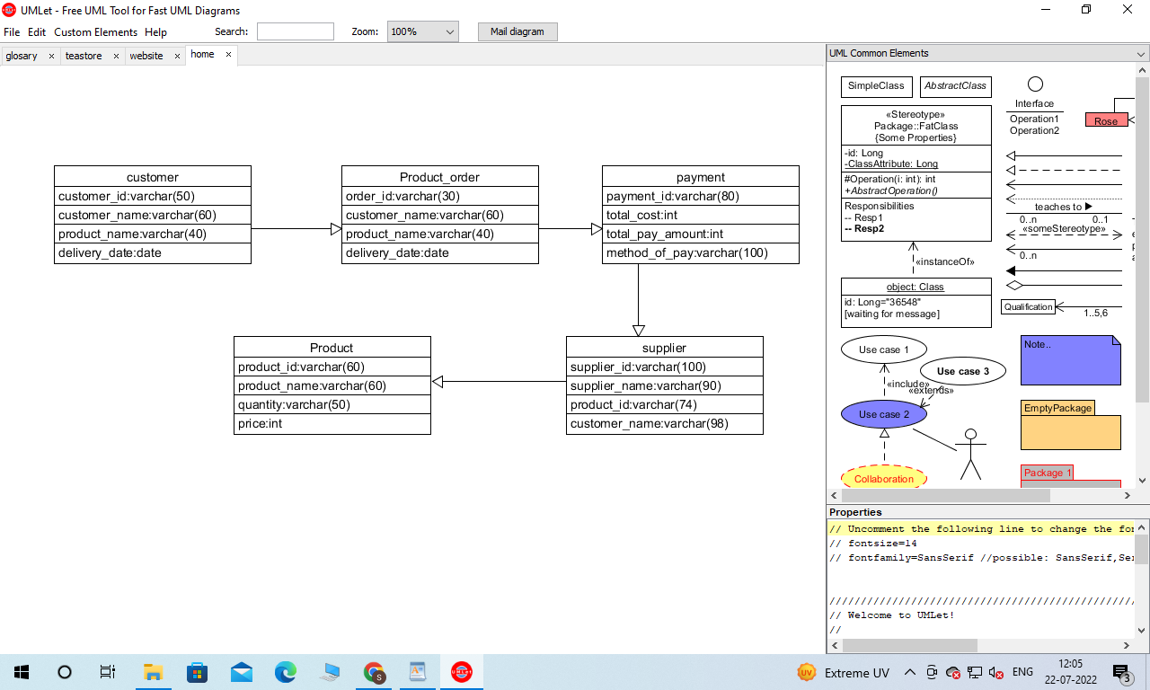

Create the second using Crow’s Foot notation in Vertabelo.

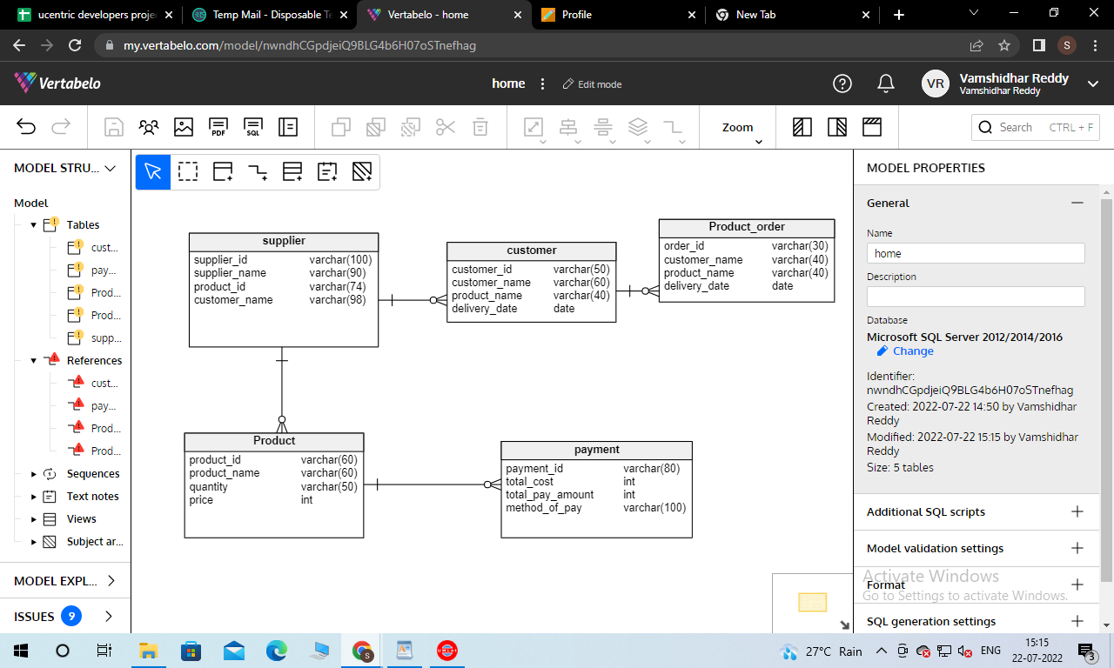

**Additional changes:**

**Description of relationship or arrows:**

From the above diagram, it can be understood that an Entity Relationship figure and UML figure showcasing the function of an E-commerce site. A flow is shown in the ER figure which starts by the customer and ends at a Product. Likewise, an interaction between a user and various components of an E-commerce site has been shown by the Use case diagram. In both the diagrams, the same entities have been used like supplier, product, customer and payment procedure. The pictorial model wants to convey a mutual relationship between the various functionalities that takes place in an e-commerce website and the unique part is that a supplier is also shown in the figure.